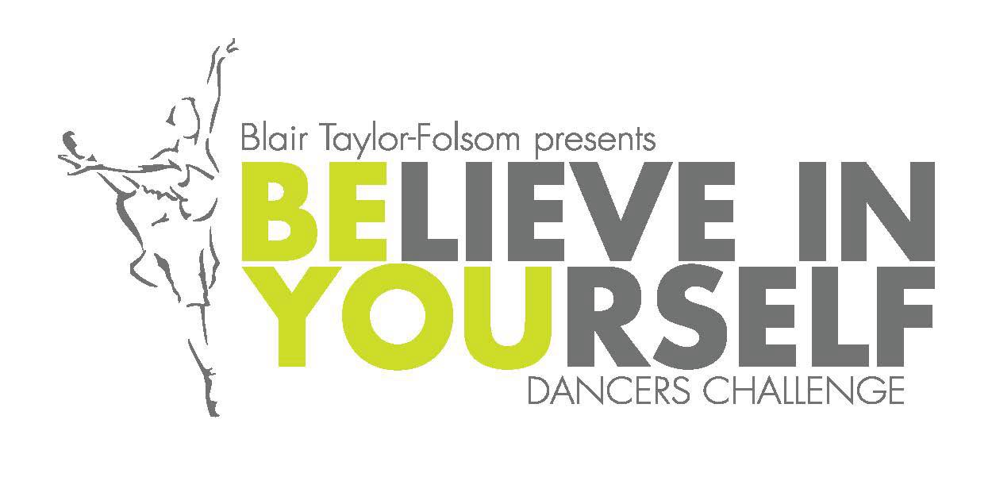
Solo Competition—Friday, March 4, 2016
Rigby High School
Participants Name: _____________________________________________________
Address: _____________________________________________________________
Home Phone Number: ______________________ Cell: ________________________
Email Address: ________________________________________________________
School Name: __________________________________ Classification: ___________
Coach Name: _________________________________________________________
Solo Category
Jazz ____ Lyrical ____
Solo Fee is $65
Entry Forms and checks must be postmarked by February 1st, 2016.
***A $15 fee will be charged for late entries***
Please make checks out to Rigby High School
c/o BYDC, 3850 E 300 N #2, Rigby, ID 83442

For any questions, please direct them to your competition director.
Blair Taylor-Folsom
208.201.4180---blairfolsom@cableone.net
This championship is a fundraiser for Breast Cancer Awareness and Diversity programs throughout Idaho.

