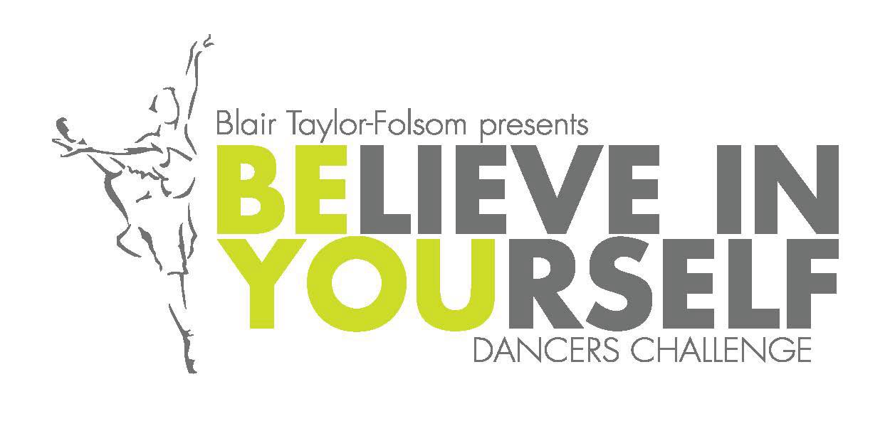
Team Competition—March 5, 2016
Rigby High School
School: ___________________________________________________ Classification ______
School Address: ______________________________________________________________
School Phone #: __________________________
COACHES INFORMATION
Head Coach: __________________________________________________________________
Cell Phone: ____________________
Assistant Coach: _______________________________________________________________
Email Address: ________________________________________________________________
CATEGORIES (Please circle all categories your team will be entering)
MILITARY DANCE KICK LYRICAL HIP HOP PROP NOVELTY
$60 per routine with a max of $250 per team entry.
Number of team members ________ T-shirt sizes XS _____ S _____ M _____ L _____ XL _____
Please write check to RIGBY HIGH SCHOOL c/o BYDC, 3850 E 300 N #2, Rigby, ID 83442
Entry Forms and checks must be postmarked by February 1st, 2016.
For any questions, please direct them to your competition director.
Blair Taylor-Folsom
208.201.4180---blairfolsom@cableone.net
This championship is a fundraiser for Breast Cancer Awareness and Diversity programs throughout Idaho.

